**Table of Contents**

1. INTRODUCTION 2
2. SCOPE 2
3. QUALITY OBJECTIVES 3
   1. Primary Objectives 3
   2. Secondary Objectives 3
4. TEST APPROACH 3
   1. Test Automation 4
5. ROLES AND RESPONSIBILITIES 4
6. ENTRY AND EXIT CRITERIA 5
   1. Entry Criteria 5
   2. Exit Criteria 5
7. SUSPENSION CRITERIA AND RESUMPTION REQUIREMENTS 5
   1. Suspension criteria 5
   2. Resumption criteria 6
8. TEST STRATEGY 6
   1. QA role in test process 6
   2. Bug life cycle: 7
   3. Testing types 8
   4. Bug Severity and Priority Definition 9

Severity List 10

Priority List 10

1. RESOURCE AND ENVIRONMENT NEEDS 11
   1. Testing Tools 11
   2. Configuration Management 11
2. TEST SCHEDULE 12

APPROVALS 13

TERMS/ACRONYMS 13

**Test Plan**



2

**Project “LIST OF TIME”**

Document Revision History

|  |  |  |  |  |  |
| --- | --- | --- | --- | --- | --- |
| Date | Version | Description | Author | Reviewer | Approver |
| 24.01 | 0.1 | Test plan was created | IGVasilev19 |  |  |
|  |  |  |  |  |  |
|  |  |  |  |  |  |
|  |  |  |  |  |  |

## INTRODUCTION

Customer wants a perfect website, which passed the full cycle of manual testing. Given the specificity of the site it is very important to have the same quality and the site.

The Test Plan has been created to facilitate communication within the team members. This document describe approaches and methodologies that will apply to the unit, integration and system testing. It includes the objectives, test responsibilities, entry and exit criteria, scope, schedule major milestones, entry and exit criteria and approach. This document has clearly identified what the test deliverables will be, and what is deemed in and out of scope.

## SCOPE

The document mainly targets the GUI testing and validating data in report output as per Requirements Specifications provided by the assignment.

* 1. Functions to be tested.
     + GUI
     + Search and Filters Logic
     + Performance
  2. Functions not to be tested.



3

1. Not other than mentioned above in section 2.1

## QUALITY OBJECTIVES

### Primary Objectives

A primary objective of testing is to: assure that the system meets the full requirements, including quality requirements (functional and non-functional requirements) and fit metrics for each quality requirement and satisfies the use case scenarios and maintain the quality of the product. At the end of the project development cycle, the user should find that the project has met or exceeded all of their expectations as detailed in the requirements.

Any changes, additions, or deletions to the requirements document, Functional Specification, or Design Specification will be documented and tested at the highest level of quality allowed within the remaining time of the project and within the ability of the QA engineer.

### Secondary Objectives

The secondary objectives of testing will be to: identify and expose all issues and associated risks, communicate all known issues to the project team, and ensure that all issues are addressed in an appropriate matter before release. As an objective, this requires careful and methodical testing of the application to first ensure all areas of the system are scrutinized and, consequently, all issues (bugs) found are dealt with.

## TEST APPROACH

The approach, that used, is Analytical therefore, in accordance to requirements-based strategy, where an analysis of the requirements specification forms the basis for planning,

estimating and designing tests. Test cases will be created during exploratory testing. All test types are determined in Test Strategy.



4

Team also must use experience-based testing and error guessing utilize testers' skills and intuition, along with their experience with similar applications or technologies.

The project is using weekly iterations. At the end of each week the requirements identified iteration will be delivered to the team and will be tested.

### Test Automation

Automated unit tests are part of the development process, during which performance data must be captured

## ROLES AND RESPONSIBILITIES

|  |  |  |
| --- | --- | --- |
| Role | Staff Member | Responsibilities |
| Project Manager | PIPetkova19 | 1. Acts as a primary contact for development. 2. Responsible for Project schedule and the overall   success of the project. |
| QA Engineer | IGVasilev19 | 1. Participation in the project plan creation/update process. Planning and organization of test process for the release. Coordinate with QA analysts/engineers on any issues/problems encountered during testing. 2. Report progress on work assignments to the PM 3. Understand requirements 4. Writing and executing Test cases 5. Preparing RTM 6. Reviewing Test cases, RTM 7. Defect reporting and tracking 8. Retesting and regression testing 9. Bug Review meeting 10. Preparation of Test Data 11. Coordinate with QA Lead for any issues or problems encountered during test preparation/execution/defect handling. |
| Front-End developer | DZGeorgiev19 | 1. Optimizing the user experience. 2. Developing and maintaining the user interface. 3. Implementing design on mobile websites. 4. Creating tools that improve site interaction regardless of the browser. 5. Managing software workflow. 6. Following SEO best practices. 7. Fixing bugs and testing for usability. |
| Back-End developer | VLMladenov19 | 1. Building and maintaining web applications. 2. Assessing the efficiency and speed of current applications. 3. Writing high-quality code. 4. Managing hosting environments. 5. Troubleshooting and debugging. 6. Keeping on top of new technologies. |

## ENTRY AND EXIT CRITERIA



5

### Entry Criteria

* All test hardware platforms must have been successfully installed, configured, and functioning properly.
* All the necessary documentation, design, and requirements information should be available that will allow the tester to operate the system and judge the correct behavior.
* All the standard software tools including the testing tools must have been successfully installed and functioning properly.
* Proper test data is available.
* The test environment such as, lab, hardware, software, and system administration support should be ready.
* Reviewed test scenarios and test cases

### Exit Criteria

* A certain level of requirements coverage has been achieved.
* No high priority or severe bugs are left unfixed.
* All high-risk areas have been fully tested, with only minor residual risks left unsolved.
* The schedule has been achieved

## SUSPENSION CRITERIA AND RESUMPTION REQUIREMENTS

### Suspension criteria

* The build contains many serious defects which seriously or limit testing progress.
* Significant change in requirements suggested by the assignment



6

* Software/Hardware problems
* Assigned resources are not available when needed by the tester.

### Resumption criteria

Resumption will only occur when the problem(s) that caused the suspension have been resolved

# TEST STRATEGY

### QA role in test process

* Understanding Requirements:
  + Requirement specifications will be set by the assignment.
  + Understanding of requirements will be done by QA
* Preparing Test Cases:

QA will be preparing test cases based on the testing. This will cover all scenarios for requirements.

* Reviewing test cases:
* Peer review will be conducted for test cases by QA Engineer
* Any comments or suggestions on test cases and test coverage will be

provided by reviewer respective Author of Test Case

* Suggestions or improvements will be re-worked by author and will be send for approval
* Re-worked improvements will be reviewed and approved by reviewer
* Creating Test Data:



7

Test data will be created by respective QA on assignment's developments/test site based on scenarios and Test cases.

* Executing Test Cases:
* Test cases will be executed by respective QA on assignment's development/test site based on designed scenarios, test cases and Test data.
* Test result (Actual Result, Pass/Fail) will be updated in test case document
* Defect Logging and Reporting:

QA will be logging the defect/bugs in Word document, found during execution of test cases. After this, QA will inform respective developer about the defect/bugs.

* Retesting and Regression Testing:

Retesting for fixed bugs will be done by respective QA once it is resolved by respective developer and bug/defect status will be updated accordingly. In certain cases, regression testing will be done if required.

* Deployment/Delivery:
* Once all bugs/defect reported after complete testing is fixed and no other bugs are found,

report will be deployed to assignment’s test site by PM.

* Once round of testing will be done by QA on assignment’s test site if required Report will be delivered along with sample output by email to respective lead and Report group.
* QA will be submitting the filled hard copy of delivery slip to respective developer.

### Bug life cycle:

All the issues found while testing will be logged into Word document.

Bug life cycle for this project is as follows:



8

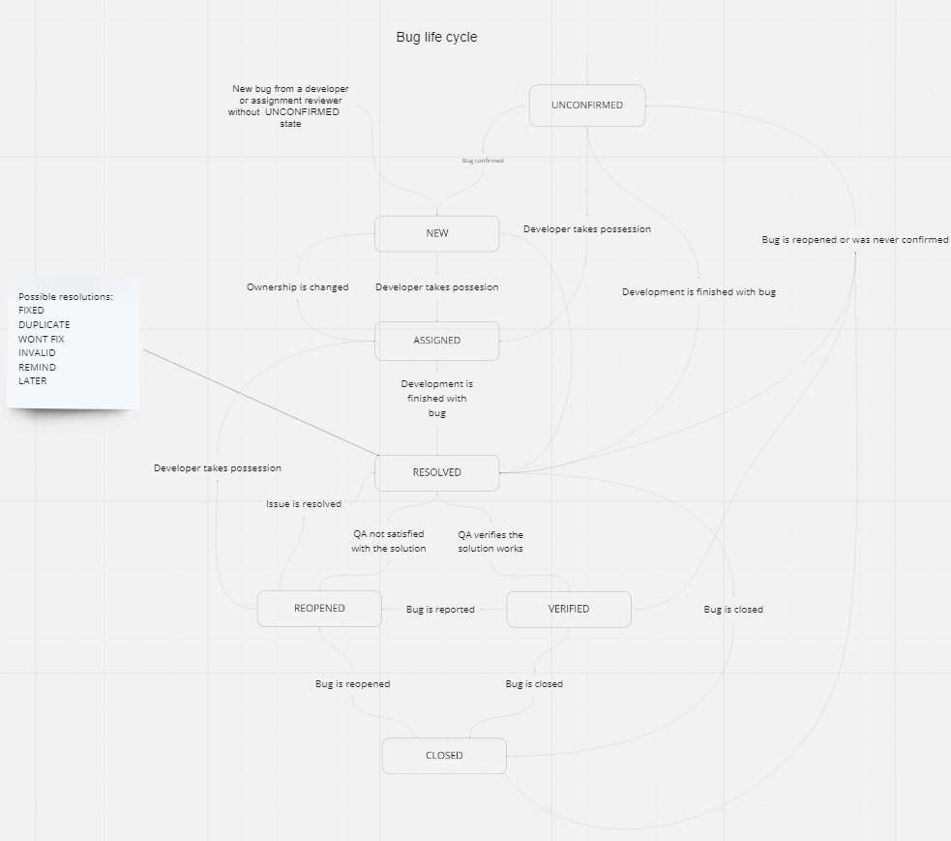

Created with: Miro

### Testing types

GUI Testing:

GUI testing will includes testing the UI part of report. It covers users Report format, look and feel, error messages, spelling mistakes, GUI guideline violations.

Functional Testing:

Functional testing is carried out in order to find out unexpected behavior of the report. The characteristic of functional testing are to provide correctness, reliability, testability and accuracy of the report output/data.

System Testing:

System testing of software is testing conducted on a complete, integrated system to evaluate the system's compliance with its specified requirements.

Performance Testing:

* Check the optimal time the page is loaded
* Check the operation of the system under load User acceptance testing:

The purpose behind user acceptance testing is to conform that system is developed according to the specified user requirements and is ready for operational use. Acceptance testing is carried out at two levels - Alpha and Beta Testing. User acceptance testing (UAT) will be done at the assignment reviewer.

Alpha testing:

The alpha test is conducted at the developer's site by client.

### Bug Severity and Priority Definition

Bug Severity and Priority fields are both very important for categorizing bugs and prioritizing if and when the bugs will be fixed. The bug Severity and Priority levels will be defined as outlined in the following tables below. Testing will assign a severity level to all bugs. The QA engineer will be responsible to see that a correct severity level is assigned to each bug.

The QA Engineer, Developers and Project Manager will participate in bug review meetings to assign the priority of all currently active bugs. The QA Engineer is responsible for setting up these meetings on a routine basis to address the current set of new and existing but unresolved bugs.



10

### Severity List

The tester is responsible for entering a bug into Severity.

|  |  |  |
| --- | --- | --- |
| **Severity ID** | **Severity** | **Severity Description** |
| 1 | Critical | The module/product crashes or the bug causes non- recoverable conditions. System crashes, GP Faults, or database or file corruption, or potential data loss, program  hangs requiring reboot are all examples of a Sev. 1 bug. |
| 2 | High | Major system component unusable due to failure or incorrect functionality. Sev. 2 bugs cause serious problems such as a lack of functionality, or insufficient or unclear error messages that can have a major impact to the user, prevents other areas of the app from being tested, etc. Sev. 2 bugs can have a  work around, but the work around is inconvenient or difficult. |
| 3 | Medium | Incorrect functionality of component or process. There is a  simple work around for the bug if it is Sev. 3. |
| 4 | Minor | Documentation errors or signed off severity 3 bugs. |

Priority List

|  |  |  |
| --- | --- | --- |
| **Priority** | **Priority Leel** | **Priority Description** |
| 1 | Must Fix | This bug must be fixed immediately; the product can’t ship with this bug. |
| 2 | Should Fix | These are important problems that should be fixed as soon as possible. It would be an embarrassment to the company  if this bug shipped. |

|  |  |  |
| --- | --- | --- |
| 3 | Fix When Have  Time | The problem should be fixed within the time available. If  the bug does not delay shipping date, then fix it. |
| 4 | Low Priority | It is not important (at this time) that these bugs be addressed. Fix these bugs after all other bugs have been fixed. Enhancements/ Good to have features incorporated-  just are out of the current scope. |



11

## RESOURCE AND ENVIRONMENT NEEDS

### Testing Tools

|  |  |
| --- | --- |
| Process | Tool |
| Test case creation | Microsoft Excel |
| Test case tracking | Microsoft Excel |
| Test case execution | Manual, by Unit testing |
| Test case management | Microsoft Excel |
| Defect management | Microsoft Word |
| Test reporting | PDF |
| Check list creating | Microsoft Excel |

### Configuration Management

* Code CM: Git Hub

## TEST SCHEDULE

|  |  |  |  |  |
| --- | --- | --- | --- | --- |
| **Task Name** | **Start** | **Finish** | **Effort** | **Comments** |
| Test Planning | 24.01 | 29.01 |  |  |
| Review Requirements  documents | 24.01 | 16.02 |  |  |
| Create test basis | 24.01 | 16.02 |  |  |
| Staff and train new test  resources |  |  |  |  |
| First deploy to QA test  environment |  | |  |  |
| Functional testing –  Iteration 1 |  |  |  |  |
| Iteration 2 deploy to QA  test environment |  |  |  |  |
| Functional testing –  Iteration 2 |  |  |  |  |
| System testing |  |  |  |  |
| Regression testing |  |  |  |  |
| UAT |  |  |  |  |
| Resolution of final defects  and final build testing |  |  |  |  |
| Deploy to Staging  environment |  |  |  |  |
| Performance testing |  |  |  |  |
| Release to Production |  |  |  |  |

# APPROVALS:



13

|  |  |  |
| --- | --- | --- |
|  | **Project Manager** | **QA Engineer** |
| **Name** |  |  |
| **Signature** |  |  |

## TERMS/ACRONYMS

The below terms are used as examples, please add/remove any terms relevant to the document.

|  |  |
| --- | --- |
| **TERM/ACRONYM** | **DEFINITION** |
| API | Application Program Interface |
| GUI | Graphical user interface |
| PM | Project manager |
| UAT | User acceptance testing |
| CM | Configuration Management |
| QA | Quality Assurance |
| SEO | Search Engine Optimization |